The North Coast NSW Human Research Ethics Committee (NCNSW HREC) provides scientific and ethical review of human research ethics applications for research that takes place within institutions governed by Northern New South Wales (NNSW) and/or Mid North Coast (MNC) Local Health Districts (LHDs); and/or external institutions/organisations and/or for research that is undertaken by independent researchers within the geographical boundaries of NNSW and MNC LHDs as approved by the HREC Chairperson.
Please use the following checklist to ensure your application meets the minimum submission requirements to be deemed eligible for review by the HREC. IMPORTANT: Failure to complete and upload this checklist will result in the application being deemed ineligible, requiring a revised submission, which could delay study commencement.
Submitting a new ethics application to the NCNSW HREC requires the following elements:
- A Human Research Ethics Application (HREA) completed in the Research Ethics Governance Information System (REGIS) including:
  - this completed checklist, AND
  - all study documents – e.g., study protocol, participant information sheet and consent form, etc.
Check each box below to confirm completion of the associated action and submit this checklist with the HREA Application via REGIS. If you need assistance, please email the Executive Officer, NCNSW HREC:
NNSWLHD-Ethics@health.nsw.gov.au
Once your HREA has been submitted, you can expect an email stating whether your application has been deemed eligible for review by the HREC.
Meeting dates and submission deadlines are as follows:
Meeting dates and Submission deadlines are published online.
Please note: the Executive Committee may only review lower risk research and the NCNSW HREC can review both lower risk research and higher risk research HREC. Please see Chapter 2.1 of the National Statement for further guidance on risk profiles of research.
Contacts:
If you need assistance with your application please email the Executive Officer, NCNSW HREC: NNSWLHD-Ethics@health.nsw.gov.au

If you need assistance with your study design, or you wish to discuss research collaboration, please see the following contact lists: Northern NSW Local Health District or Mid North Coast Local Health District

Research Governance Officer, NNSWLHD: NNSWLHD-ResearchGovernance@health.nsw.gov.au
Research Governance Officer, MNCLHD: MNCLHD-RGO@health.nsw.gov.au

1. | Ethical Review Pathway  All research conducted within NNSW and/or the MNC LHDs involving participants (e.g., patients, including their health information, or health service employees) must undergo ethical and scientific review and obtain approval before commencing (see NSW Health Policy Directive PD2010_055 and Section 5 of the National Statement). This review ensures research is conducted in accordance with the National Health and Medical Research Council (NHMRC) National Statement on Ethical Conduct in Human Research (the National Statement).  If the study is to be led by an employee or agent of NNSW and/or MNC LHD and the study poses no risk of harm or discomfort (see Chapter 2.1 of the National Statement), there is a non-HREC review process for ethical and scientific review, which serves the same purpose as HREC review (see Chapters 5.1.12 to 5.1.14 and 5.1.17 the National Statement), but is more expeditious. Where appropriate, this is the preferred ethical review pathway as it is more efficient for all parties. If you consider your project may be suitable for non-HREC review, please review the relevant application criteria:  - Northern NSW Local Health District (see section “Quality Activities”)  - Mid North Coast Local Health District (see section “Quality Project Registration Form”)  Ethical and Scientific Review Pathways  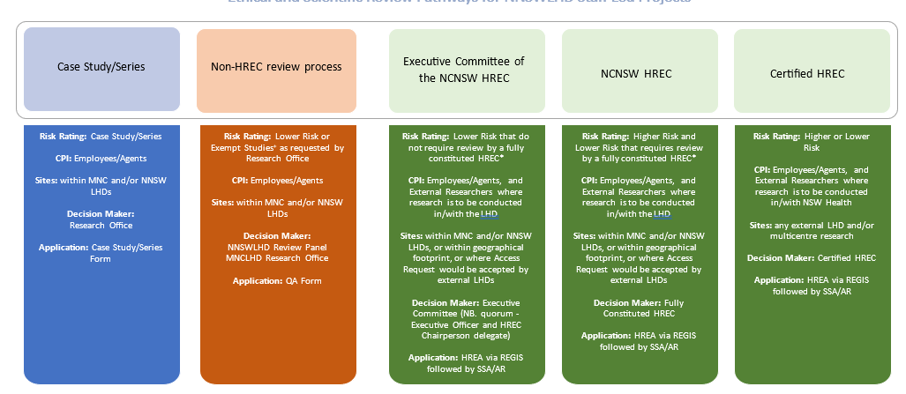  I have read the advice above and confirm the NCNSW HREC review is most appropriate.  ☐
2. | Scientific Merit, Study Design and Supervision Expectations  The NCNSW HREC will consider the ethical and scientific merits of the HREA but expects investigators who are new to research or have limited research knowledge and experience to conduct their activity, will conduct their research under supervision (clinical and/or academic) or in collaboration with co-investigators that have research experience. The NCNSW HREC also expects investigators to engage experts for statistical analysis and other specialist requirements where appropriate (e.g. health economists). Statisticians, supervisors, and other research experts should be named in the HREA and Protocol and be engaged in the development of the research activity prior to HREA submission (i.e. during planning and development). This is particularly relevant to data analysis (it is not adequate to propose consultation with a statistician once data has been collected). It is expected supervisors are actively involved in the study design and have reviewed the HREA prior to submission. If you are an employee/agent of NNSW or MNC LHDs and you are an inexperienced researcher or this is your first HREC application, please contact your Research Office for assistance.  I have read the advice above and confirm that I have the knowledge and experience to undertake the research activity OR engaged with the Research Office, AND/OR developed the research activity and documents with people who have research experience/qualifications.  ☐
3. | Correct Site/s and Principal Investigators Nominated  At REGIS Project Registration, the site/s and associated Principal Investigators (PI), who will have responsibility for the conduct/management of the study at the site, are named. In most instances, the PI is an employee/agent of the LHD. Before the HREA is submitted for review, please ensure this information is correct. Incorrect naming of sites and/or investigators will result in the HREA being returned to you for amendment and may delay study site authorisation.  When conducting research across more than one site within the same LHD (e.g. hospitals), it may be more efficient to instead name the LHD as the site e.g. Northern NSW LHD.  If you are unsure about whether the named PI and/or site may be appropriate, please consult with the relevant Research Governance Officer (contact details below) to confirm.  I have read the advice above and confirm the Principal Investigator/s and site/s named are correct.  ☐
4. | Study Material  The NCNSW HREC requires that all HREAs are submitted using the NCNSW HREC approved templates, including the study protocol and (where relevant) a Participant Information Sheet and Consent Form. See: NCNSW HREC Resources and Forms for accessing to templates and proformas.  In addition, ensure you submit all relevant study material including (but not limited to):  - Recruitment Invitations such as letter/email, telephone script, text message script etc.  - Survey Tools / Questionnaires  - Semi-Structured Interview Questions  - Focus Group Prompts  - Recruitment Advertisements / Flyers  Please ensure relevant study documents appropriately include a pre-amble and post-amble providing the potential participant information necessary to inform their decision on whether to participate (e.g. survey tool, interview questions, focus group prompts).  ☐  I have read the advice above and confirm the submission includes a Protocol using the NCNSW HREC Template and (where relevant) Participant Information Sheet and Consent Form and all other relevant study material.
4. | NSW eHealth Supported Platforms  Please ensure compliance with the eHealth Video Conferencing Platforms Guidelines. Note: Microsoft Teams and Pexip are the preferred options. Zoom is not to be used for sharing confidential information.  Online Survey Platforms are generally ethically acceptable and there is no preferred platform (e.g. QARS, REDcap, Qualtrics). Please note some platforms are not accessible on the NSW Health network (e.g. Google Forms). SurveyMonkey is acceptable, however it is important to inform potential participants (via Participant Information Sheet and/or Survey Introductory Pre-amble) that data are stored in servers hosted in the United States of America and are subject to privacy laws of that country. Please see the following guidance provided by the NSW Education Standard Authority (NESA; SurveyMonkey Privacy Notice) for guidance. The same may apply to other platforms.  ☐  I have read the advice above and confirm NSW eHealth Supported Platforms have been utilised.
5. | Document Management  Study document naming conventions. Please adopt meaningful and practical study document naming conventions and version control including the following guidance:  - Files should be named consistently  - File names should be short but descriptive (ideally, <25 characters)  - Avoid special characters (*, %) or spaces in a file name  - Use capitals and underscores instead of periods or spaces or slashes  - Use date format ISO 8601: YYYYMMDD  - Include a version number  - Write down naming convention in data management plan  For example, “StudyProtocol_v2_2023-07-02”, “PIS_Staff_Interviews_v1_2023-07-02”.  NOTE: In REGIS, the “Document Descriptor" should employ the same logic as this is how it will be listed on the approval notification.  Study document version control. Please include the document title and version control in the footer of all study documents. The version control should reflect, in an iterative manner, the versions submitted for review in successive order. For example, in the initial submission, all study documents will be version 1. Once the documents have been edited and revised, the document becomes version 2 (v2), and this is updated in the document title and document footer.  I have read the advice above and confirm the study documents submitted have a document title, REGIS document description, and embedded version control as described  above.  ☐

